AIRGUARD AI

AI-Powered Urban Air Quality Intelligence Platform

Detailed Project Document

Submitted for
ET AI Hackathon 2.0 – Phase 2 (Build Sprint)

Problem Statement
Urban Air Quality Intelligence Platform

Submitted By
Team Name: tanishka.garg2025
Team Members:
- Tanishka Garg
- Pranaviha Ganeshkumar

Submission Date
19 July, 2026

Table of Contents
S. No. | Contents
1 | Abstract
2 | Problem Statement
3 | Existing Challenges
4 | Proposed Solution
5 | Project Objectives
6 | System Features
7 | System Architecture
8 | Workflow Diagram
9 | Methodology
10 | Technology Stack
11 | Dataset Description
12 | AI Models & Algorithms
13 | Module Description
14 | User Interface
15 | Results & Expected Impact
16 | Future Scope
17 | Conclusion
18 | References

1. Abstract
Air pollution has emerged as one of the most pressing environmental and public health challenges in urban areas, driven by rapid urbanization, increasing vehicular emissions, industrial activities, construction dust, and biomass burning. While existing air quality monitoring systems provide city-level Air Quality Index (AQI) values, they often lack localized predictions, actionable insights, and intelligent decision-support capabilities for both authorities and citizens.
AirGuard AI is an AI-powered Urban Air Quality Intelligence Platform designed to transform air quality monitoring into proactive decision-making. The platform predicts ward-level AQI using historical air quality and weather data, identifies major pollution sources through source attribution, and provides AI-driven intervention recommendations to help municipal authorities take timely and effective actions.
To enhance situational awareness, the system features an interactive geospatial dashboard with ward-wise AQI visualization, pollution heatmaps, trend analysis, and hotspot detection. It also offers personalized health advisories for different groups of citizens, including children, the elderly, asthma patients, and outdoor workers, enabling them to take appropriate precautions based on current and predicted air quality conditions. Additionally, an AI-powered chatbot allows users to interact with the system using natural language, while the Intervention Cost & Impact Analysis module assists authorities in selecting the most effective pollution control strategies.
The platform integrates Machine Learning, geospatial visualization, and data-driven analytics to convert environmental data into meaningful insights for smarter urban management. By enabling early prediction, informed decision-making, and proactive intervention, AirGuard AI aims to support cleaner air, healthier communities, and sustainable smart city development.

2. Problem Statement
Urban air pollution has become a significant challenge due to rapid urbanization, increasing vehicular traffic, industrial emissions, construction activities, and biomass burning. Poor air quality directly impacts public health, environmental sustainability, and the overall quality of life. Although air quality data is available through monitoring stations, it is often limited to city-level observations and does not provide localized insights or predictive intelligence required for timely decision-making.
Municipal authorities require a system that not only monitors air quality but also predicts future pollution levels, identifies the major pollution sources, recommends effective interventions, and communicates health risks to citizens. A comprehensive, AI-driven platform capable of transforming environmental data into actionable insights can significantly improve urban air quality management and support smarter policy decisions.

3. Existing Challenges
Current air quality monitoring systems face several limitations that reduce their effectiveness in supporting proactive environmental management.

Key Challenges
- Air quality information is generally available only at the city level, making it difficult to identify pollution variations across different wards or localities.
- Existing systems primarily focus on monitoring current AQI rather than predicting future air quality conditions.
- Authorities often lack data-driven recommendations for selecting appropriate pollution control measures.
- Pollution sources such as traffic, industries, construction activities, and biomass burning are not clearly identified, making targeted intervention difficult.
- Citizens receive limited personalized health guidance based on prevailing air quality conditions.
- Environmental data is fragmented across multiple sources, making comprehensive analysis and decision-making challenging.
- Most existing platforms provide static reports instead of interactive visualizations that simplify interpretation for decision-makers.
These limitations highlight the need for an integrated intelligent platform capable of prediction, analysis, visualization, and decision support.

4. Proposed Solution
AirGuard AI is an AI-powered Urban Air Quality Intelligence Platform that combines Machine Learning, geospatial visualization, and environmental analytics to enable proactive air quality management. The platform predicts ward-level AQI, identifies the dominant pollution sources, and provides intelligent intervention recommendations to assist municipal authorities in making informed decisions.
The system presents pollution data through an interactive dashboard featuring geospatial heatmaps, AQI trends, pollution hotspot analysis, and ward-wise comparisons. It also delivers personalized health advisories for different categories of citizens and includes an AI-powered chatbot for quick access to air quality information. Additionally, the Intervention Cost & Impact Analysis module helps authorities evaluate different pollution control measures based on their estimated effectiveness and implementation cost.
By integrating prediction, visualization, and intelligent recommendations into a single platform, AirGuard AI transforms raw environmental data into actionable insights that support cleaner, healthier, and more sustainable cities.

5. Project Objectives
The primary objectives of AirGuard AI are:
- Develop an AI-powered platform for accurate hyperlocal AQI prediction at the ward level.
- Identify the major contributors responsible for urban air pollution using pollution source attribution techniques.
- Provide AI-driven intervention recommendations to assist municipal authorities in reducing pollution levels.
- Visualize pollution distribution through interactive ward-wise maps, heatmaps, and analytical dashboards.
- Generate personalized health advisories to help citizens minimize exposure to poor air quality.
- Support informed decision-making by comparing the cost and expected impact of different pollution control measures.
- Improve public awareness through an AI-powered conversational assistant capable of answering air quality-related queries.
- Promote proactive, data-driven, and sustainable urban air quality management using Artificial Intelligence.

6. System Features
AirGuard AI integrates Artificial Intelligence, Machine Learning, geospatial visualization, and environmental analytics into a unified platform that enables authorities and citizens to monitor, predict, and respond to urban air pollution effectively.
Feature | Description
Hyperlocal AQI Prediction | Predicts ward-level Air Quality Index (AQI) for the next 24–72 hours using historical AQI and weather data.
Interactive Geospatial Pollution Intelligence | Displays ward-wise AQI, pollution hotspots, and heatmaps on an interactive city map.
Pollution Source Attribution | Identifies the dominant pollution sources such as traffic, industries, construction, and biomass burning.
AI Intervention Recommendation Engine | Suggests the most suitable pollution control measures based on predicted AQI and pollution sources.
Citizen Health Advisory System | Provides health recommendations for children, elderly people, asthma patients, outdoor workers, and the general public.
Intervention Cost & Impact Analysis | Compares different pollution control measures based on implementation cost and expected AQI improvement.
AI Pollution Assistant (Chatbot) | Answers user queries related to AQI, pollution sources, health precautions, and recommended actions.
Interactive Decision Dashboard | Integrates maps, charts, predictions, alerts, recommendations, and analytics into a single monitoring platform.

7. System Architecture
The architecture of AirGuard AI follows a modular pipeline that transforms environmental data into actionable insights for authorities and citizens.
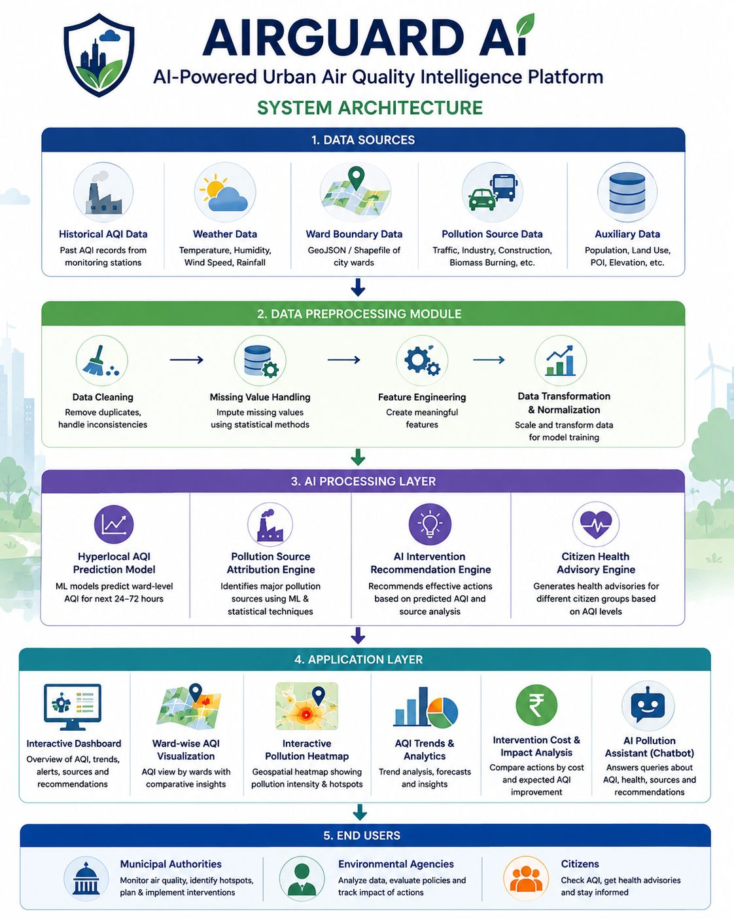

Architecture Description
The system begins by collecting environmental information from multiple sources, including historical AQI records, weather conditions, traffic data, industrial emission indicators, construction activity data, and ward boundary information.
The collected data is processed through a preprocessing module where missing values are handled, features are prepared, and datasets are standardized for analysis.
The processed data is then passed to the AI Engine, which consists of four major components:
- AQI Prediction Model
- Pollution Source Attribution Engine
- AI Recommendation Engine
- Citizen Health Advisory Engine
The outputs generated by these AI modules are integrated into the Application Layer, where users can access the Interactive Dashboard, Geospatial Heatmap, AI Chatbot, Cost & Impact Analysis, and Ward-wise AQI information.
Finally, the system presents all insights through an intuitive user interface, enabling municipal authorities and citizens to make informed, data-driven decisions for pollution management.

8. Workflow Diagram
The operational workflow of AirGuard AI follows a sequential pipeline that converts raw environmental data into intelligent recommendations.
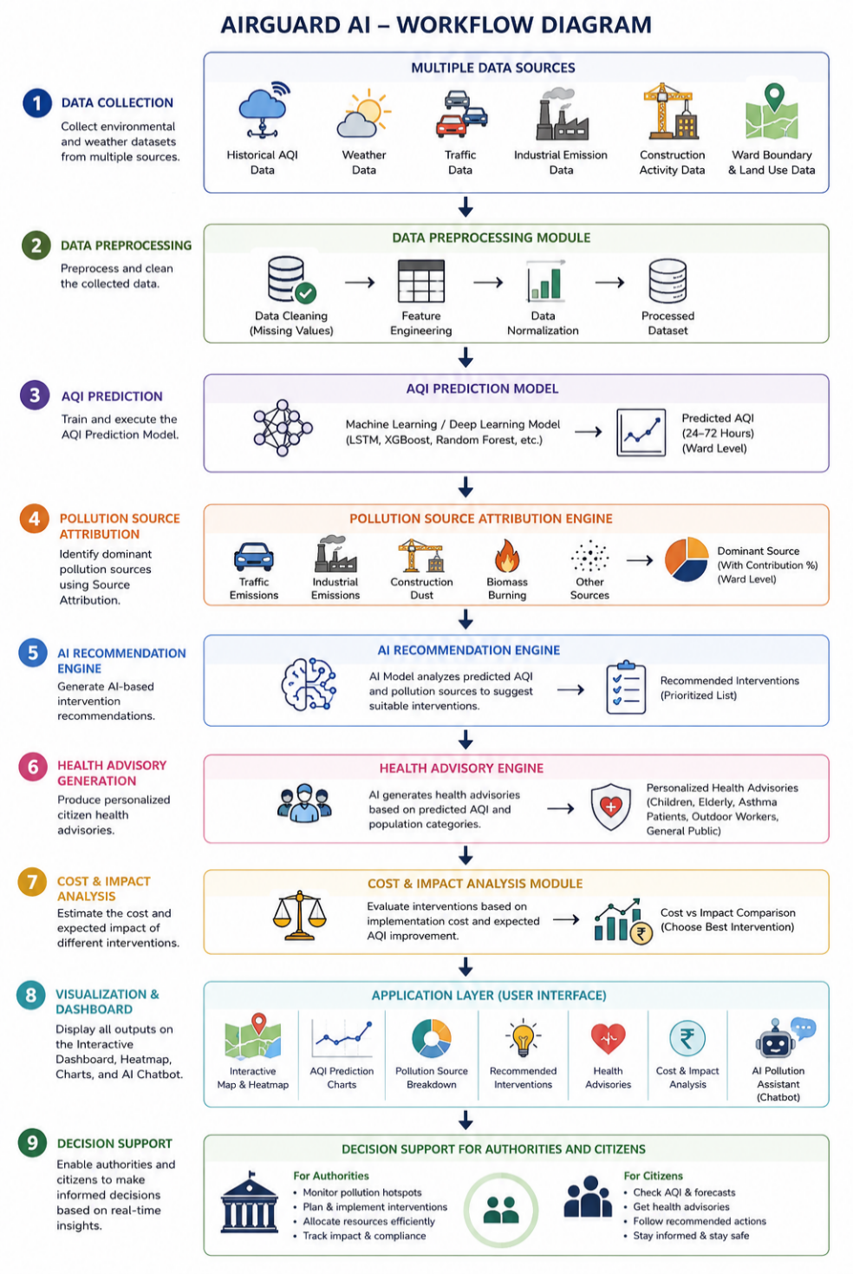

Workflow Description
- Collect environmental and weather datasets from multiple sources.
- Preprocess and clean the collected data.
- Train and execute the AQI Prediction Model.
- Identify dominant pollution sources using Source Attribution.
- Generate AI-based intervention recommendations.
- Produce personalized citizen health advisories.
- Estimate the cost and expected impact of different interventions.
- Display all outputs on the Interactive Dashboard, Heatmap, Charts, and AI Chatbot.
- Enable authorities and citizens to make informed decisions based on real-time insights.

9. Methodology
AirGuard AI follows a structured pipeline that transforms raw environmental data into actionable insights using Artificial Intelligence and data analytics. The complete workflow is divided into five major stages.

Step 1: Data Collection
The system collects air quality and environmental information from multiple sources, including:
- Historical AQI Data
- Weather Data
- Ward Boundary (GeoJSON) Data
- Pollution Source Data
These datasets provide the foundation for training prediction models and generating location-specific insights.

Step 2: Data Preprocessing
The collected data undergoes preprocessing before analysis.
This stage includes:
- Removing duplicate records
- Handling missing values
- Data normalization
- Feature engineering
- Preparing datasets for machine learning
The objective is to improve data quality and ensure accurate model predictions.

Step 3: AI Processing
The processed data is analyzed using AI models and rule-based logic.
The system performs the following tasks:
- Hyperlocal AQI Prediction
- Pollution Source Attribution
- AI Intervention Recommendation
- Citizen Health Advisory Generation
These modules work together to convert environmental data into meaningful intelligence.

Step 4: Visualization & Decision Support
The processed outputs are displayed through an interactive dashboard containing:
- Ward-wise AQI Map
- Pollution Heatmap
- AQI Trend Charts
- Pollution Source Analysis
- Cost & Impact Analysis
- AI Chatbot
This enables authorities and citizens to understand pollution conditions quickly and make informed decisions.

Step 5: Actionable Outcomes
The final stage provides decision-support outputs such as:
- Predicted AQI
- High-risk wards
- Pollution hotspots
- Recommended interventions
- Citizen health alerts
- Cost-effective pollution control strategies
These insights help authorities take timely preventive measures instead of reactive actions.

10. Technology Stack
The project combines Artificial Intelligence, Machine Learning, and geospatial visualization to build an intelligent air quality monitoring platform.
Component | Technology Used
Programming Language | Python
Frontend | HTML, CSS, JavaScript
Backend | Flask
Machine Learning | Scikit-learn
Data Processing | Pandas, NumPy
Data Visualization | Chart.js
Geospatial Visualization | Leaflet.js + OpenStreetMap
Heatmap Generation | Leaflet Heat Plugin
AI Chatbot | Gemini API
Development Environment | Visual Studio Code
Version Control | Git & GitHub

11. Dataset Description
AirGuard AI utilizes multiple datasets to provide accurate air quality prediction and intelligent decision support.
Dataset | Purpose
Historical AQI Data | Train the AQI prediction model using past air quality records.
Weather Data | Improve prediction accuracy using temperature, humidity, wind speed, and rainfall.
Ward Boundary (GeoJSON) Data | Visualize ward-wise AQI and generate interactive pollution maps.
Pollution Source Data | Estimate the contribution of traffic, industries, construction activities, and biomass burning.

Data Preprocessing Techniques
Before model training, the following preprocessing steps are performed:
- Missing value handling
- Duplicate record removal
- Feature selection
- Data normalization
- Dataset transformation
These preprocessing techniques improve the quality of the data and enhance the performance of the prediction model.

Expected Dataset Features
The prediction model primarily utilizes the following attributes:
- Date & Time
- Ward ID
- AQI
- PM2.5
- PM10
- NO₂
- SO₂
- CO
- O₃
- Temperature
- Humidity
- Wind Speed
- Rainfall
These features collectively enable accurate AQI prediction and support the system’s analytical and recommendation capabilities.

12. AI Models & Algorithms
AirGuard AI combines machine learning, rule-based decision logic, geospatial analytics, and generative AI to provide intelligent air quality monitoring and decision support. Each module is designed to solve a specific aspect of urban air quality management.

12.1 Hyperlocal AQI Prediction

Objective
Predict the Air Quality Index (AQI) for individual wards for the next 24–72 hours using historical air quality and weather data.

Proposed Model
Random Forest Regressor

Why Random Forest?
- High prediction accuracy
- Handles multiple environmental features effectively
- Robust against overfitting
- Suitable for tabular environmental datasets
- Easy to train and interpret

Input Features
- Historical AQI
- PM2.5
- PM10
- NO₂
- SO₂
- CO
- O₃
- Temperature
- Humidity
- Wind Speed
- Rainfall

Output
- Predicted AQI
- AQI Category
- High-Risk Ward Identification

12.2 Pollution Source Attribution

Objective
Identify the dominant factors contributing to poor air quality in each ward.

Method
A rule-based scoring mechanism analyzes pollution indicators and estimates the contribution of:
- Traffic
- Industrial Emissions
- Construction Activities
- Biomass Burning

Output
- Dominant Pollution Source
- Source Contribution Distribution
- Pollution Severity Level

12.3 AI Intervention Recommendation Engine

Objective
Generate intelligent recommendations for reducing pollution levels.

Method
The recommendation engine combines:
- Predicted AQI
- Pollution Source
- AQI Severity
- Environmental Conditions
Based on these inputs, the system suggests the most appropriate pollution control measures.

Sample Recommendations
- Restrict Heavy Vehicle Movement
- Increase Public Transport
- Water Sprinkling on Roads
- Construction Dust Suppression
- Industrial Emission Inspection
- Urban Plantation Drives

12.4 Citizen Health Advisory Engine

Objective
Provide personalized health recommendations based on predicted AQI levels.

Method
The advisory engine maps AQI categories to predefined health guidelines for different user groups.

Target Users
- Children
- Elderly People
- Asthma Patients
- Outdoor Workers
- General Citizens

Output
- Health Alerts
- Outdoor Activity Recommendations
- Mask Recommendations
- Safety Precautions

12.5 AI Pollution Assistant

Objective
Enable users to interact with the platform using natural language.

Technology
Google Gemini API

Capabilities
The AI assistant can answer questions related to:
- Current AQI
- Predicted AQI
- Pollution Sources
- Health Precautions
- Recommended Interventions
- General Air Quality Awareness
The chatbot makes the platform more interactive by providing instant, easy-to-understand responses to user queries.

13. Module Description
The AirGuard AI platform consists of interconnected modules that work together to provide comprehensive air quality intelligence.

Module 1 – Data Management
Purpose
Collect and preprocess environmental datasets.
Functions
- Data Collection
- Data Cleaning
- Missing Value Handling
- Feature Engineering
Output
Clean dataset for AI processing.

Module 2 – AQI Prediction
Purpose
Predict future AQI at the ward level.
Functions
- Historical Data Analysis
- Machine Learning Prediction
- AQI Classification
Output
Ward-wise AQI Forecast.

Module 3 – Pollution Analysis
Purpose
Identify the primary causes of air pollution.
Functions
- Pollution Source Attribution
- Hotspot Detection
- Pollution Trend Analysis
Output
Source Contribution Analysis.

Module 4 – Recommendation System
Purpose
Generate actionable pollution control strategies.
Functions
- AI Recommendation Generation
- Priority Ranking
- Cost & Impact Analysis
Output
Recommended Intervention Plan.

Module 5 – Health Advisory
Purpose
Provide health guidance based on air quality conditions.
Functions
- AQI Risk Assessment
- Citizen Health Alerts
- Safety Recommendations
Output
Personalized Health Advisory.

Module 6 – Interactive Dashboard
Purpose
Present insights through an intuitive interface.
Functions
- AQI Dashboard
- Ward-wise Heatmap
- Charts & Analytics
- KPI Cards
Output
Interactive Decision Support Dashboard.

Module 7 – AI Pollution Assistant
Purpose
Allow users to access air quality information using natural language.
Functions
- Answer User Queries
- Explain AQI Levels
- Provide Health Guidance
- Explain Recommended Actions
Output
Conversational AI Assistance powered by the Google Gemini API.

14. User Interface

The AirGuard AI prototype provides a simple, interactive, and user-friendly interface for monitoring air quality, analyzing pollution trends, and supporting decision-making.

14.1 Landing Page

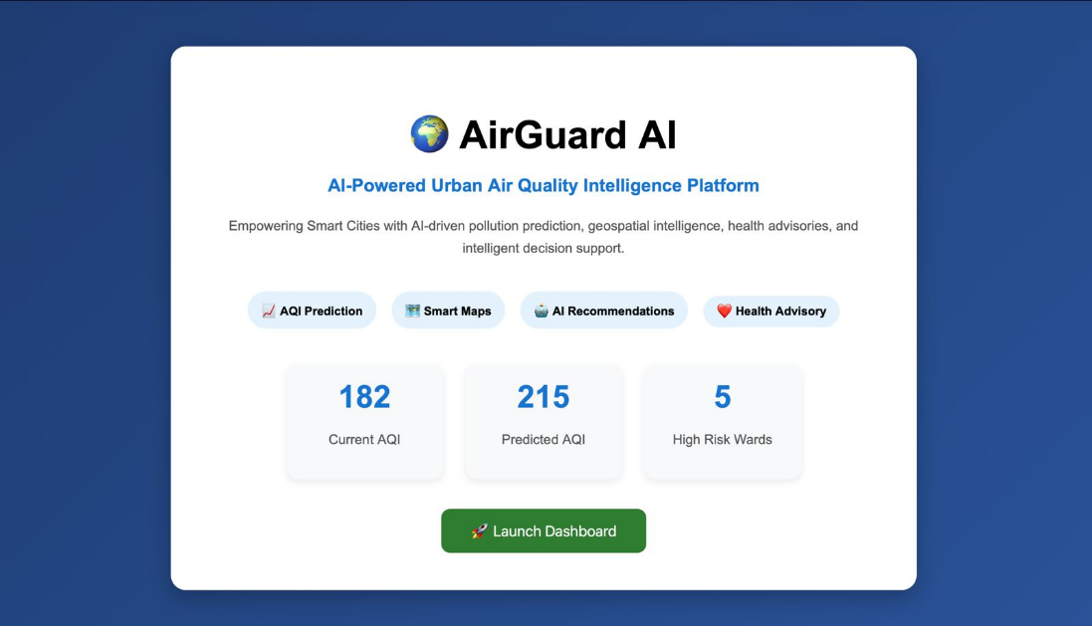
Description:
- Introduces the AirGuard AI platform.
- Highlights key features of the system.
- Displays important AQI statistics.
- Provides access to the main dashboard.

14.2 Dashboard Overview

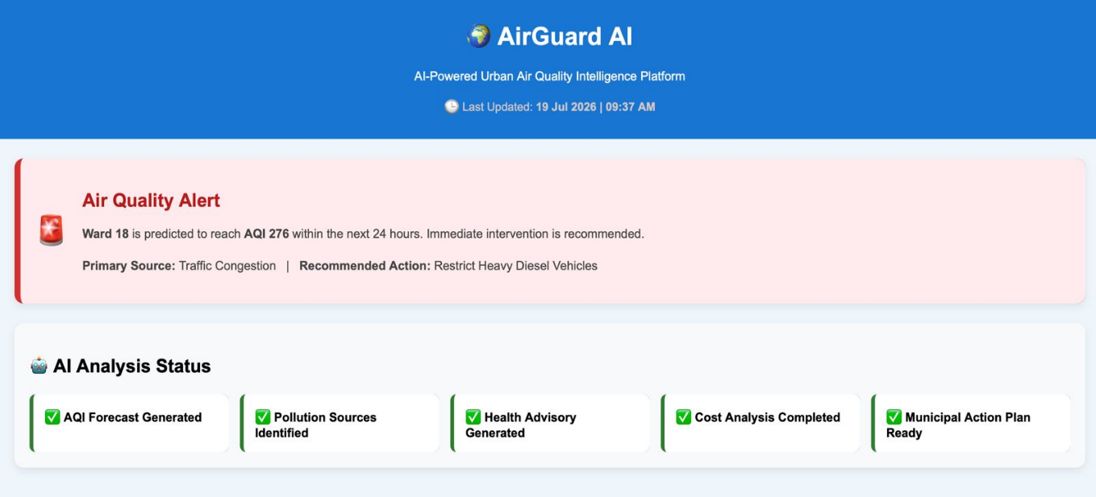
Description:
- Displays real-time air quality alerts.
- Shows latest system status and analysis.
- Highlights critical pollution information.
- Summarizes AI-generated outputs.

14.3 Smart KPI Cards

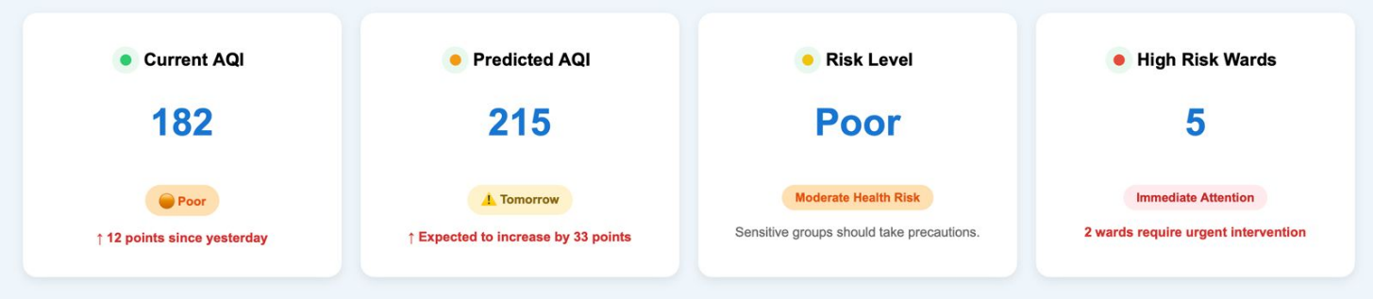
Description:
- Displays current and predicted AQI.
- Shows overall risk level.
- Indicates the number of high-risk wards.
- Uses color indicators for quick understanding.

14.4 AQI Trend Analysis

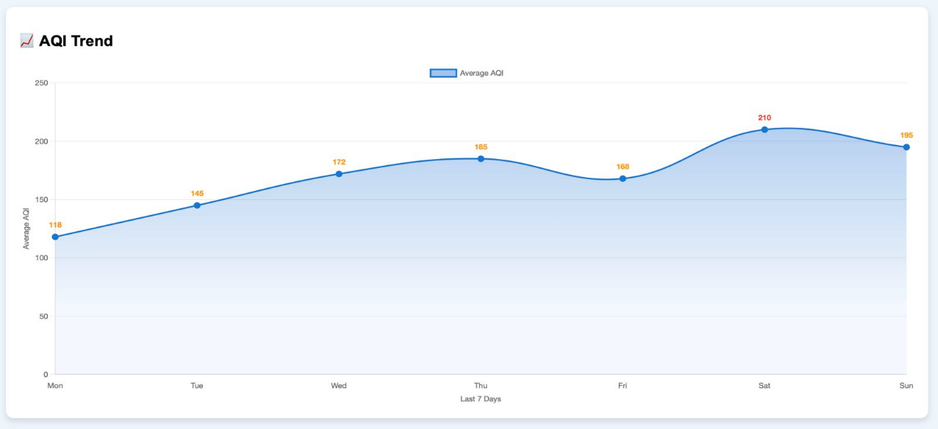
Description:
- Visualizes AQI changes over time.
- Helps identify pollution trends.
- Supports future air quality analysis.

14.5 Interactive Pollution Map

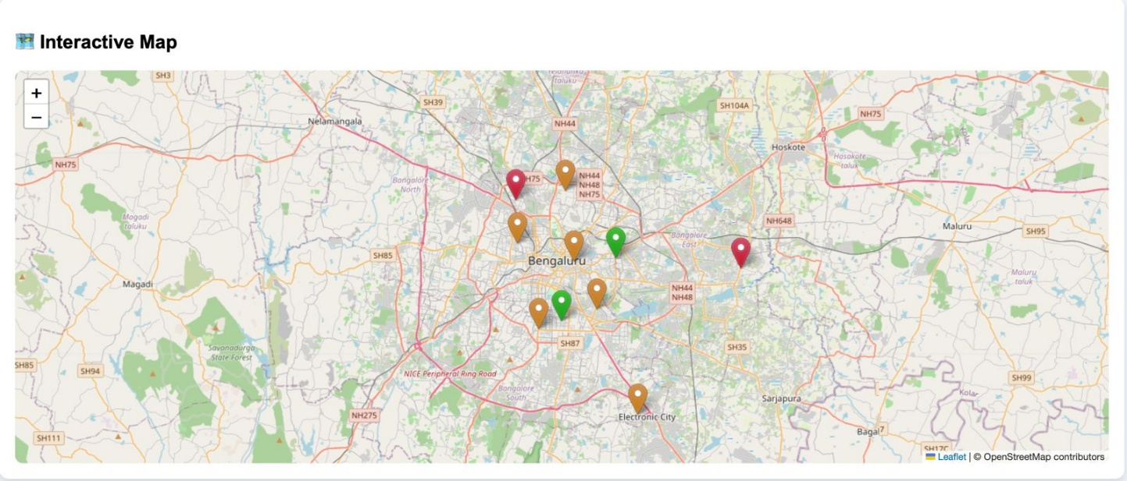
Description:
- Displays pollution hotspots on a city map.
- Uses color-coded location markers.
- Helps identify affected areas.

14.6 Pollution Source Analysis

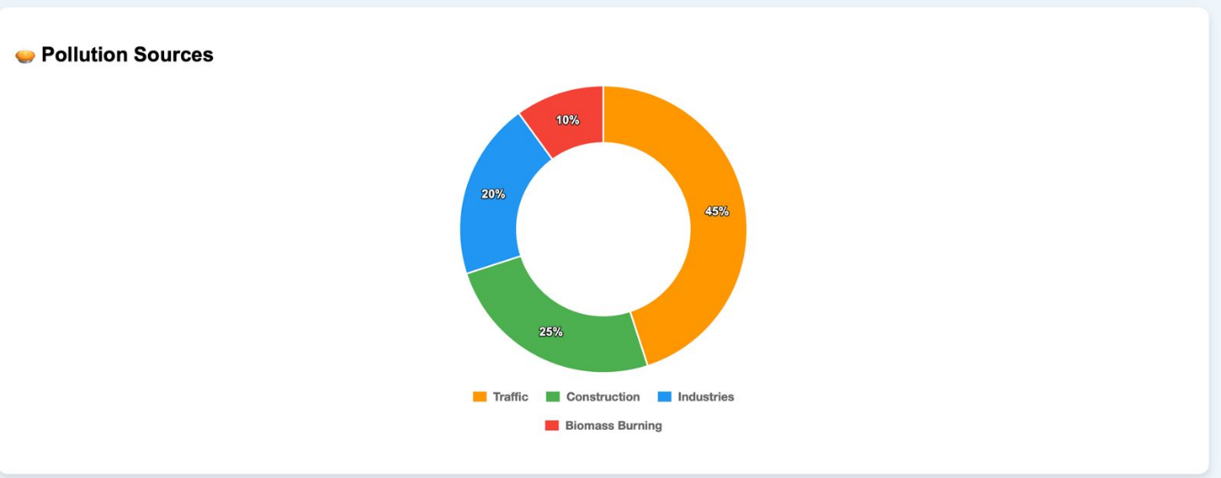
Description:
- Shows major pollution sources.
- Represents their percentage contribution.
- Supports pollution source identification.

14.7 AI Recommendations

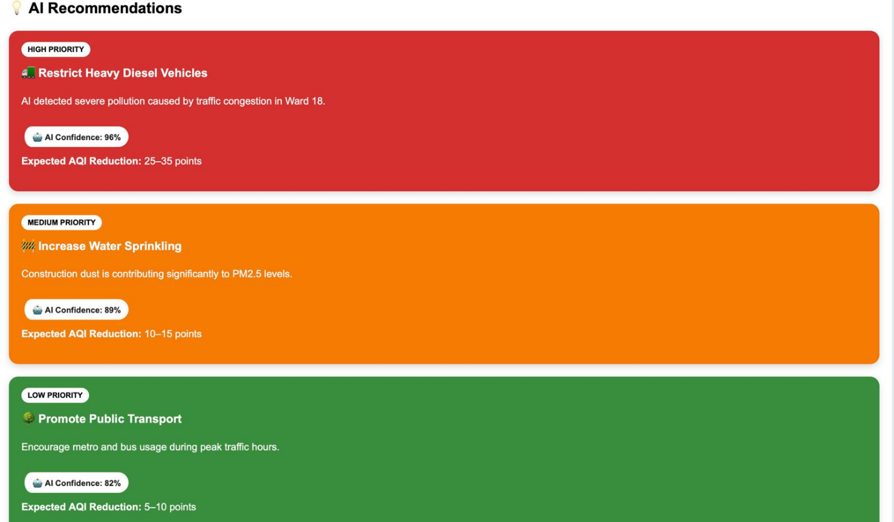

Description:
- Displays AI-generated action plans.
- Categorizes recommendations by priority.
- Shows confidence score and expected impact.

14.8 Health Advisory

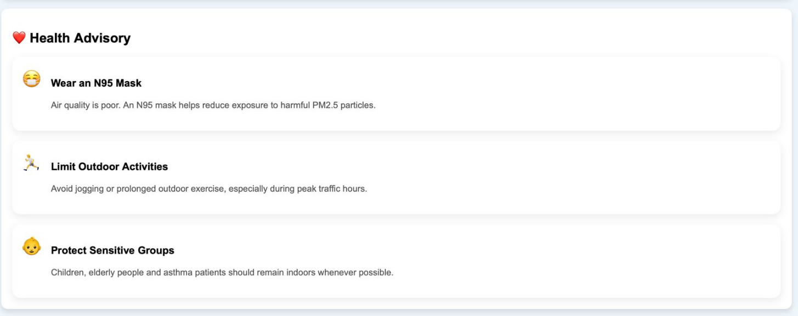
Description:
- Provides health and safety recommendations.
- Suggests preventive measures based on AQI.
- Helps protect vulnerable groups.

14.9 AI Assistant

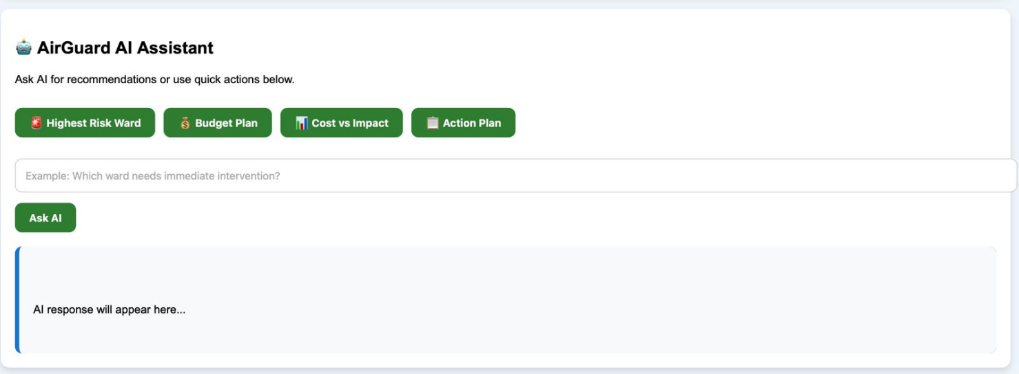
Description:
- Allows users to interact with the system.
- Provides quick action buttons.
- Answers user queries with AI-generated responses.

15. Results & Expected Impact
AirGuard AI demonstrates how Artificial Intelligence and data-driven analytics can improve urban air quality management through prediction, visualization, and intelligent decision support.

Expected Outcomes
- Accurate ward-level AQI prediction for proactive planning.
- Identification of pollution hotspots and dominant pollution sources.
- AI-driven recommendations to support municipal decision-making.
- Improved public awareness through health advisories.
- Interactive visualization for quick interpretation of environmental data.
- Enhanced accessibility through a conversational AI assistant.

Expected Benefits

For Municipal Authorities
- Data-driven pollution control planning.
- Faster identification of high-risk areas.
- Better allocation of resources.
- Support for sustainable urban governance.

For Citizens
- Timely AQI updates.
- Personalized health guidance.
- Increased awareness of pollution conditions.
- Better understanding of preventive measures.

16. Future Scope
Although AirGuard AI provides a comprehensive prototype for urban air quality intelligence, several enhancements can further increase its capabilities in future versions.
Potential improvements include:
- Integration with real-time IoT air quality sensors.
- Satellite-based pollution monitoring.
- Advanced deep learning models for improved prediction accuracy.
- Mobile application for Android and iOS platforms.
- Multi-city deployment with scalable infrastructure.
- Personalized user accounts and notification services.
- Voice-enabled AI assistant.
- Integration with Smart City platforms and municipal control centers.
- Predictive analysis for long-term pollution trends.
- Support for additional environmental parameters such as noise pollution and pollen levels.

17. Conclusion
AirGuard AI presents an intelligent, scalable, and user-friendly approach to urban air quality management by combining Artificial Intelligence, machine learning, geospatial visualization, and environmental analytics into a unified platform.
Unlike conventional air quality monitoring systems that primarily display current pollution levels, AirGuard AI enables proactive decision-making through ward-level AQI prediction, pollution source attribution, AI-powered intervention recommendations, citizen health advisories, and interactive visualization. The integration of these capabilities within a single dashboard allows both municipal authorities and citizens to better understand pollution patterns and respond effectively.
The proposed system demonstrates how data-driven technologies can support healthier communities, improve environmental governance, and contribute to the development of sustainable smart cities. AirGuard AI has the potential to serve as a practical decision-support platform for urban administrators while promoting greater public awareness regarding air quality and environmental protection.

18. References
- Central Pollution Control Board (CPCB), Government of India – Air Quality Monitoring Reports.
- World Health Organization (WHO) – Global Air Quality Guidelines.
- OpenWeatherMap API Documentation.
- Google Gemini API Documentation.
- OpenStreetMap Documentation.

- Leaflet.js Documentation.
- Scikit-learn Documentation.
- Pandas Documentation.
- NumPy Documentation.

